A Project Report

On

# Miniminds

(Online quiz for kids)

**Submitted by**

**Shivam Gupta - 2115000947**

**Anshu Pathak - 2115000166**

**Bhoovan Kumar - 2115000299**

**Gaurav Prajapati - 2115000405**

**Mentor**

Mr. Sandeep Kumar Chhoker

Technical Trainer, T&D

**Department of Training & Developement**

## GLA UNIVERSITY, MATHURA



## GLA University, Mathura - 281406

29/11/2023



**DECLARATION**

WeShivam Gupta B.Tech CS -2115000947, Anshu Pathak B.Tech CS -2115000166 Bhoovan Kumar B.Tech CS -2115000299, Gaurav Prajapati B.Tech CS -2115000405 hereby declare that the work presented in this project report entitled

“ Minminds(Online quiz for kids) ” is an authentic record of our own work carried out under supervision of Mr. Sandeep Kumar Chhoker T&D Department.

Shivam Gupta – 2115000947 Anshu Pathak – 2115000166

Bhoovan Kumar – 2115000299 Gaurav Prajapati – 2115000405

## CERTIFICATE

This is to certify that the above statement made by the students are correct to the best of my knowledge and belief.

Date: 29/11/2023

Place: Mathura

Mr. Sandeep Kumar Chhoker

Technical Trianer, T&D



# Contents

Certificate & Declaration 2

Table of Contents 3

1. **Introduction 4**
2. **Project Description and Work done 5-15**
3. **Conclusion 16**

Bibliography/ References 17



# Introduction

MiniMinds is an engaging and interactive online quiz platform designed specifically for kids. The project aims to provide a fun and educational experience for children while enhancing their cognitive skills through a variety of quizzes covering different subjects.

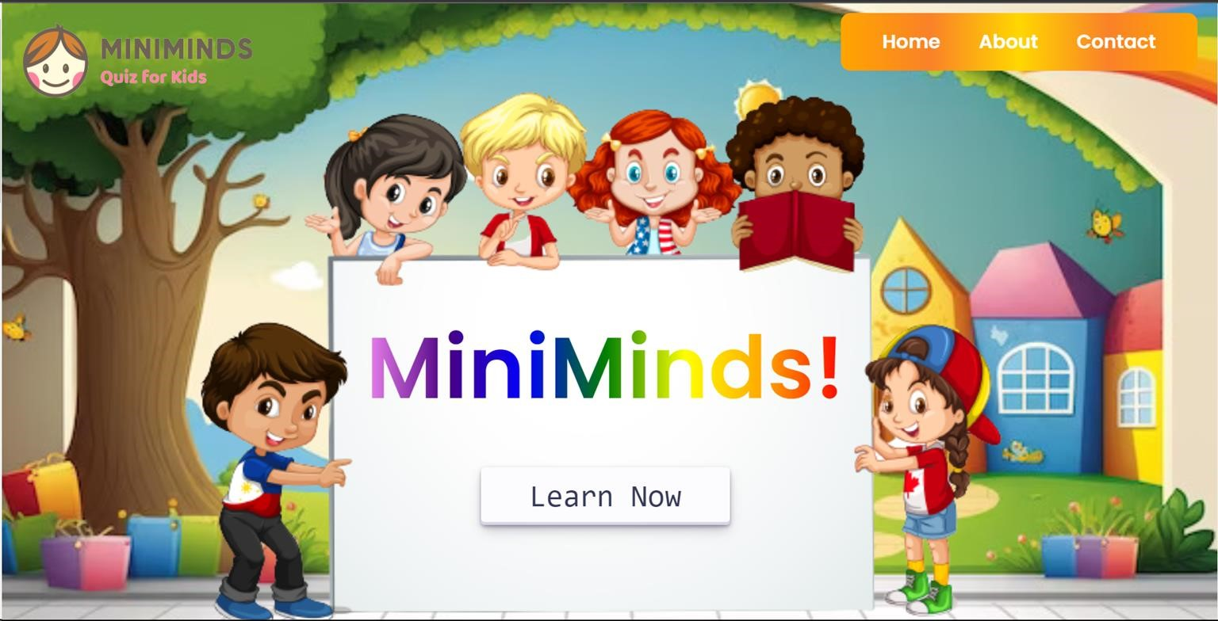



# Project description & Work done

Miniminds utilizes a user-friendly interface where kids can choose from a selection of quizzes categorized by subjects. The platform guides them through a series of questions with colorful visuals and age-appropriate content. Instant feedback is provided, fostering a positive learning environment.

## Technology used:-

Front-End Development **:** The front-end of MiniMinds is built using HTML, CSS, and JavaScript. These technologies work together to create an intuitive and visually appealing user interface.HTML structures the content, CSS styles the elements,and JavaScript adds interactivity, making the quizzes engaging for kids.

Back-End Development **:** Backend development involves the server-side of web and application development. It focuses on managing and processing data, ensuring the application's functionality, and handling interactions with databases, external services, and other server-related tasks. Here are some key topics in backend development:

1. **Server-side Programming Languages:**

**Node.js**: JavaScript runtime built on Chrome's V8 engine. It allows developers to use JavaScript for server-side scripting.

1. **Databases:**

**Relational Databases (SQL):** Such as MySQL, PostgreSQL, SQLite. They use structured query language (SQL) to manage and manipulate structured data.

1. **Backend Frameworks**:

**Express.js (for Node.js):** A minimal and flexible Node.js web application framework.

1. **API (Application Programming Interface**):

**RESTful APIs:** Follow the principles of Representational State Transfer, using standard HTTP methods (GET, POST, PUT, DELETE).



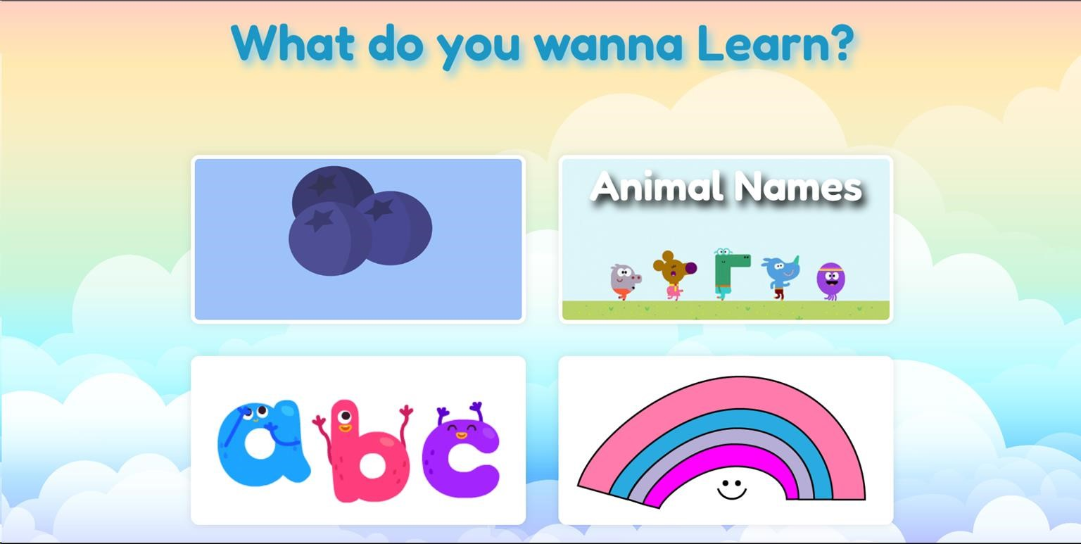

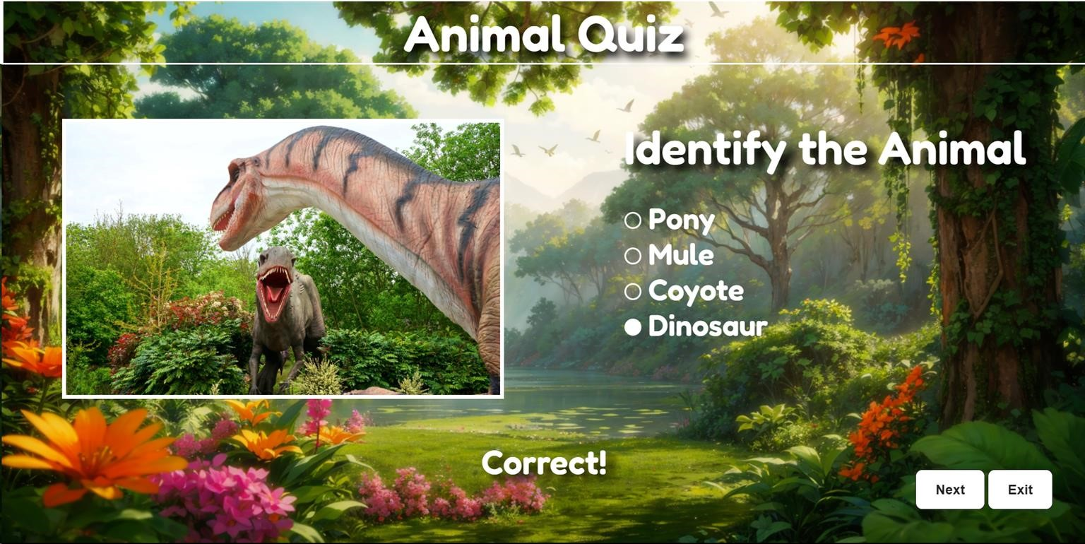

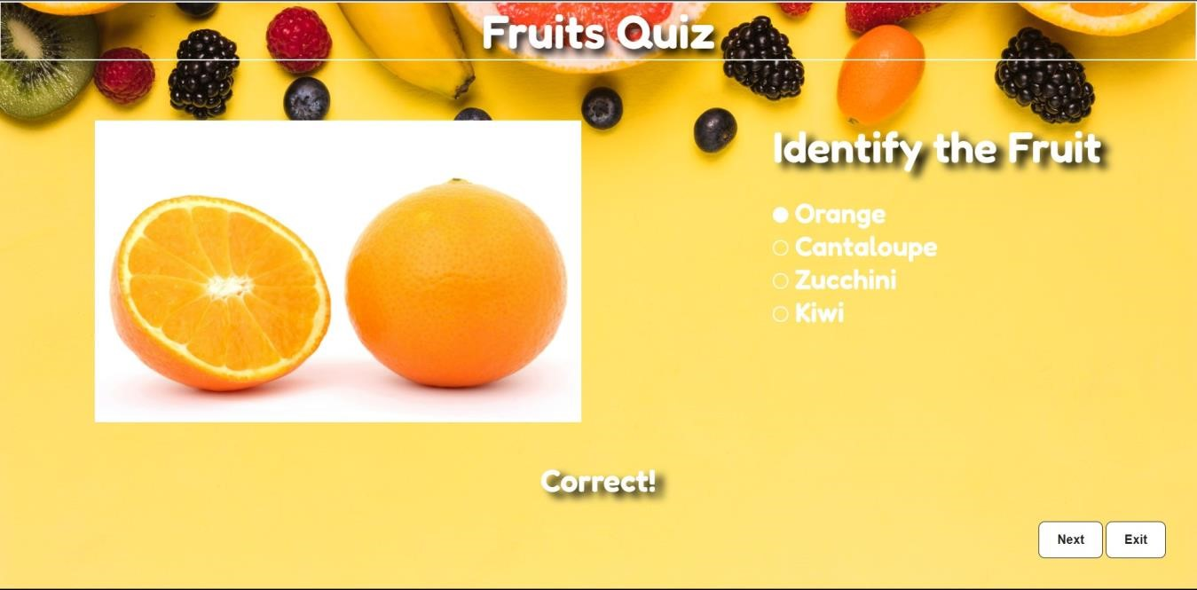

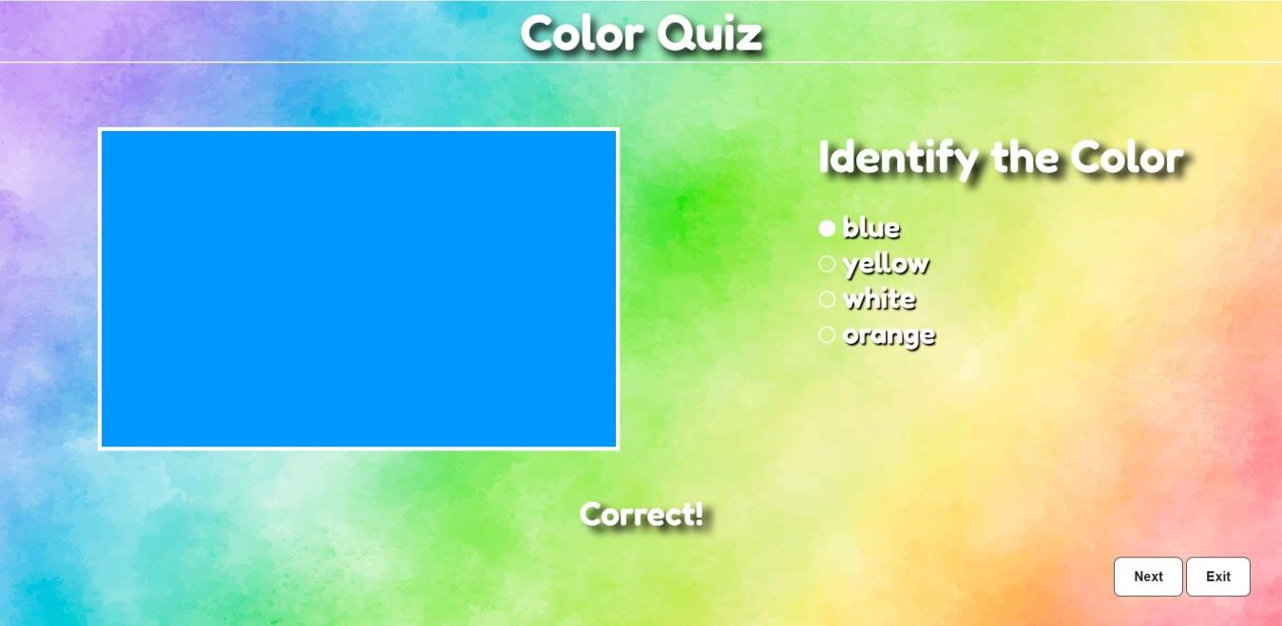

# Programming Guide

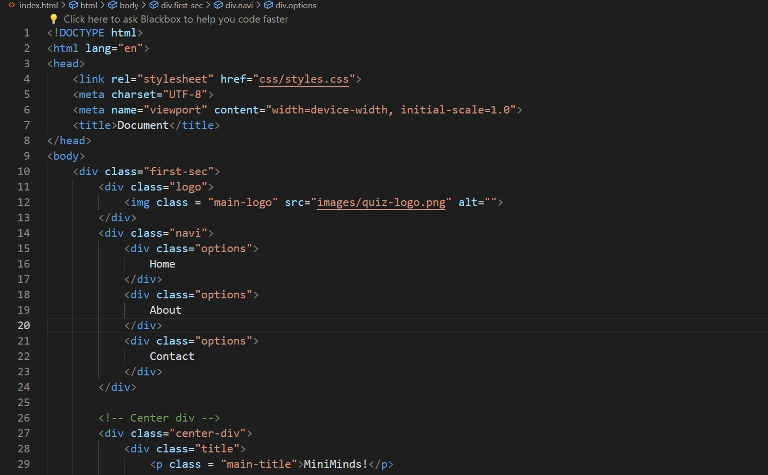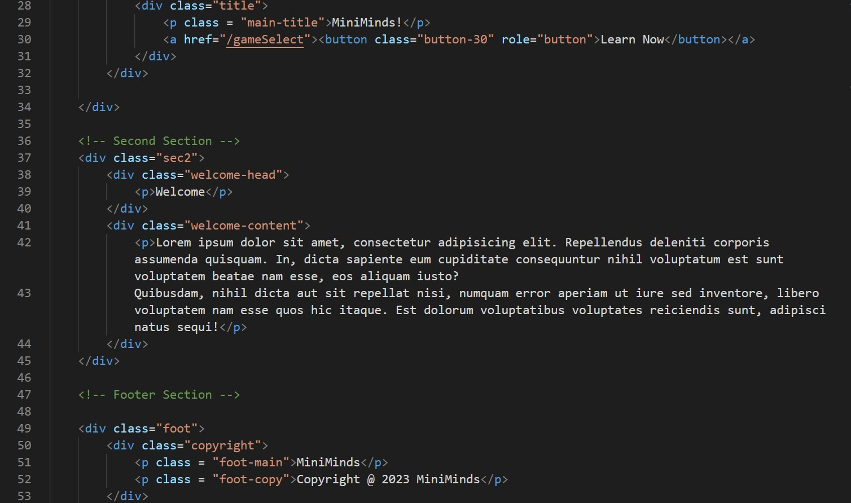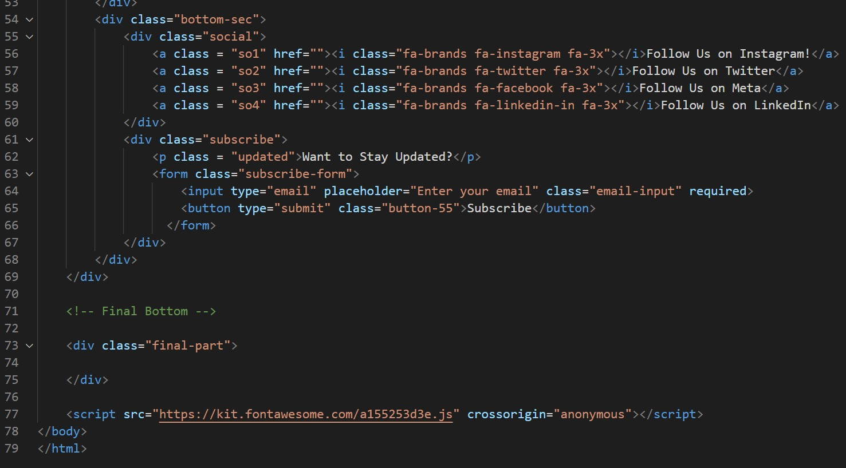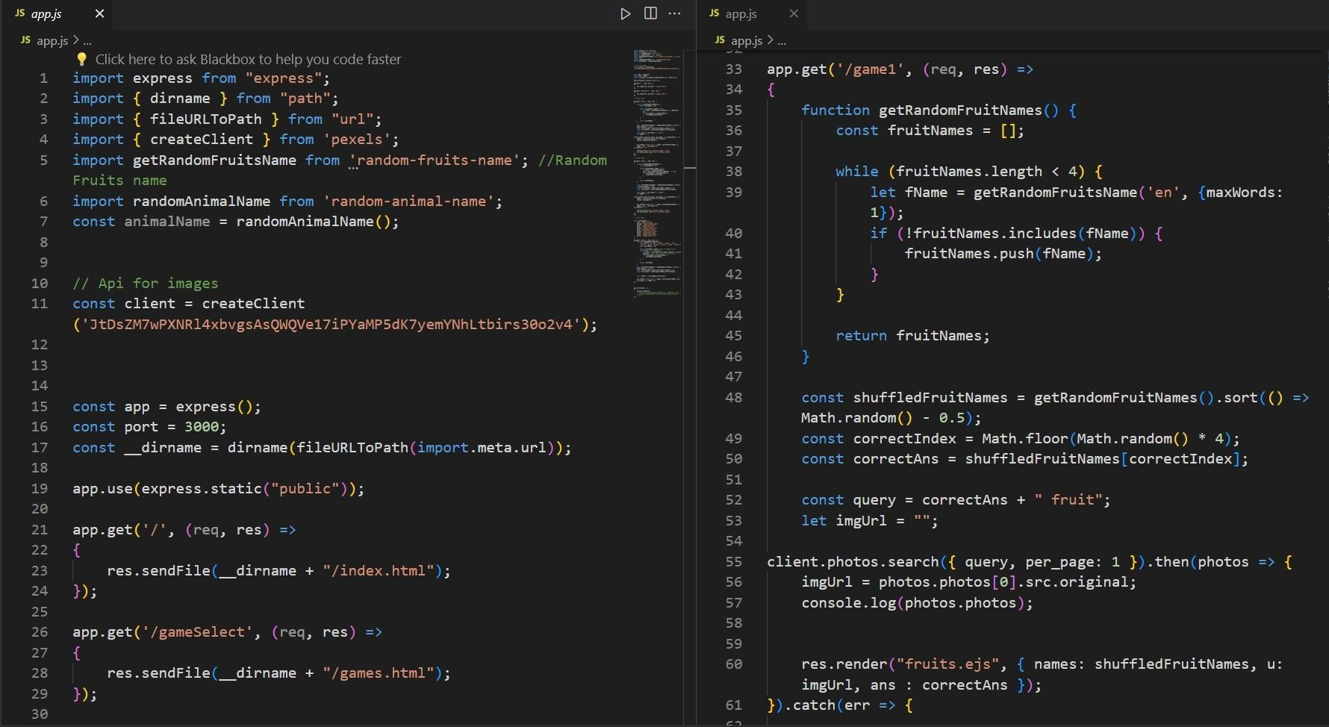

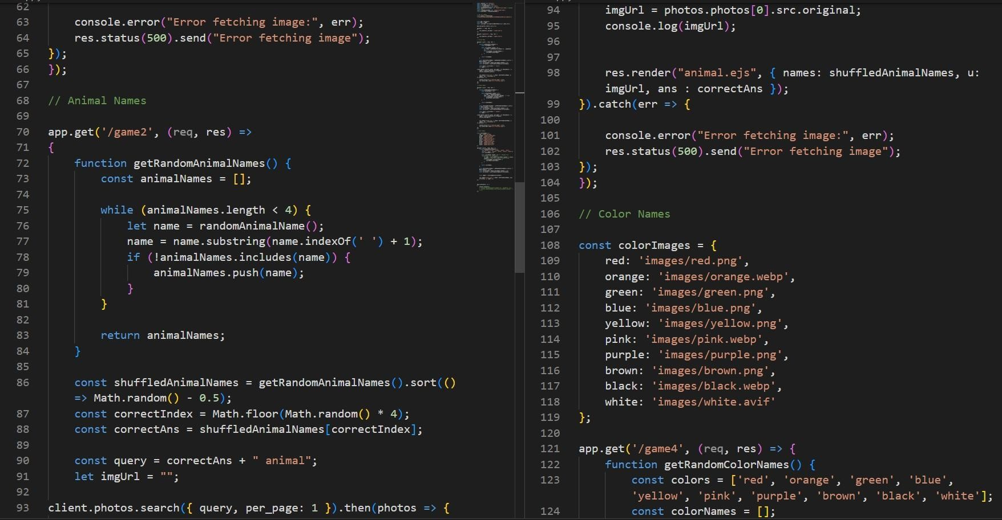

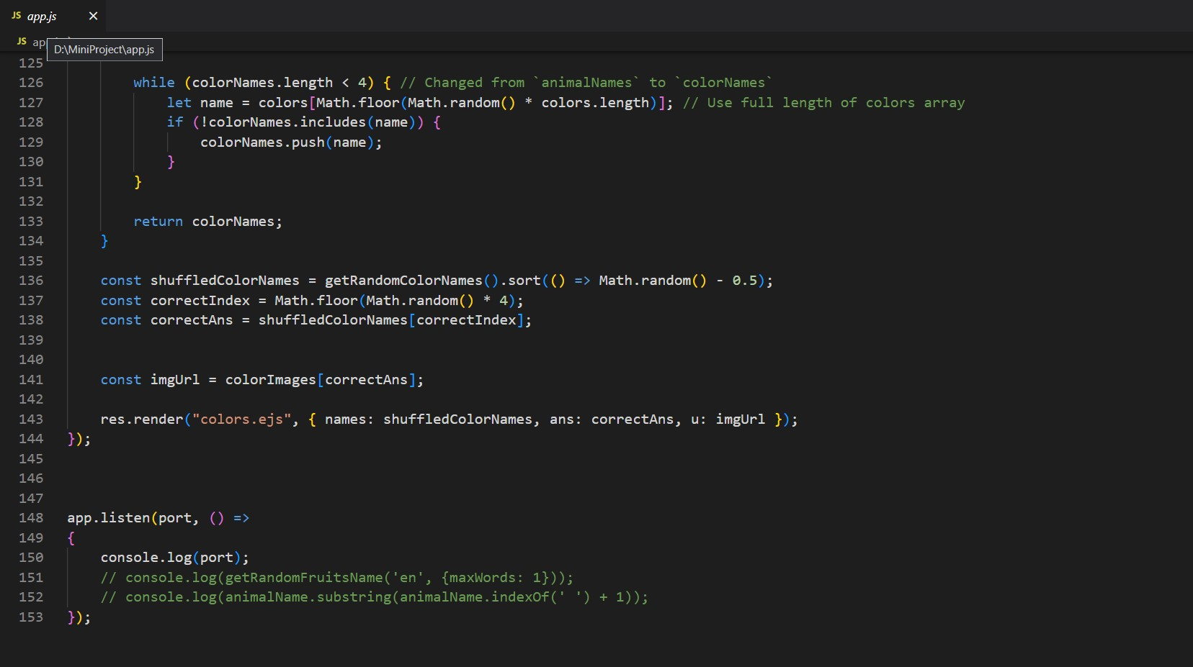

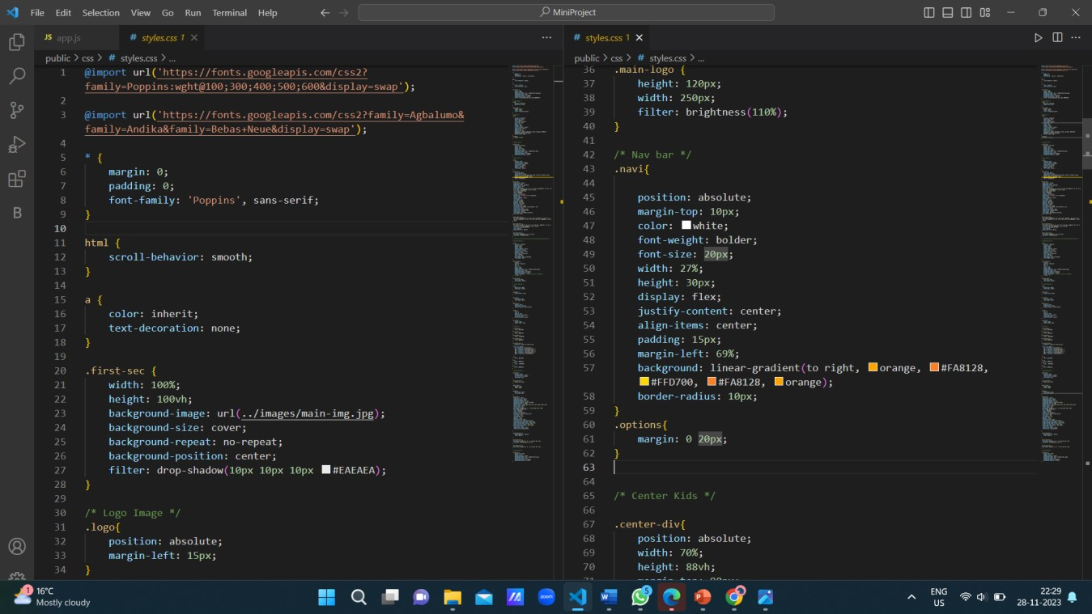

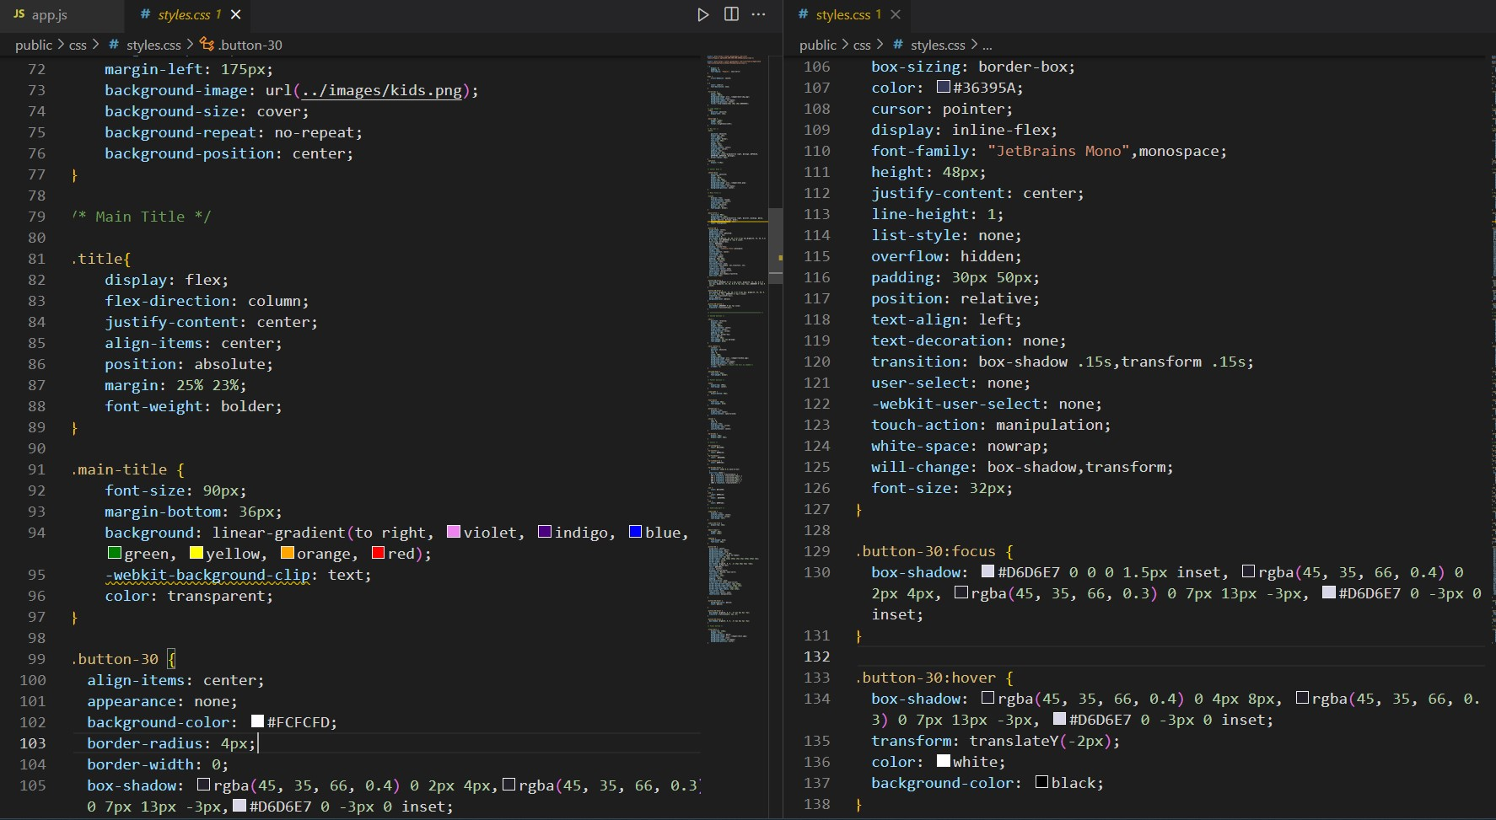



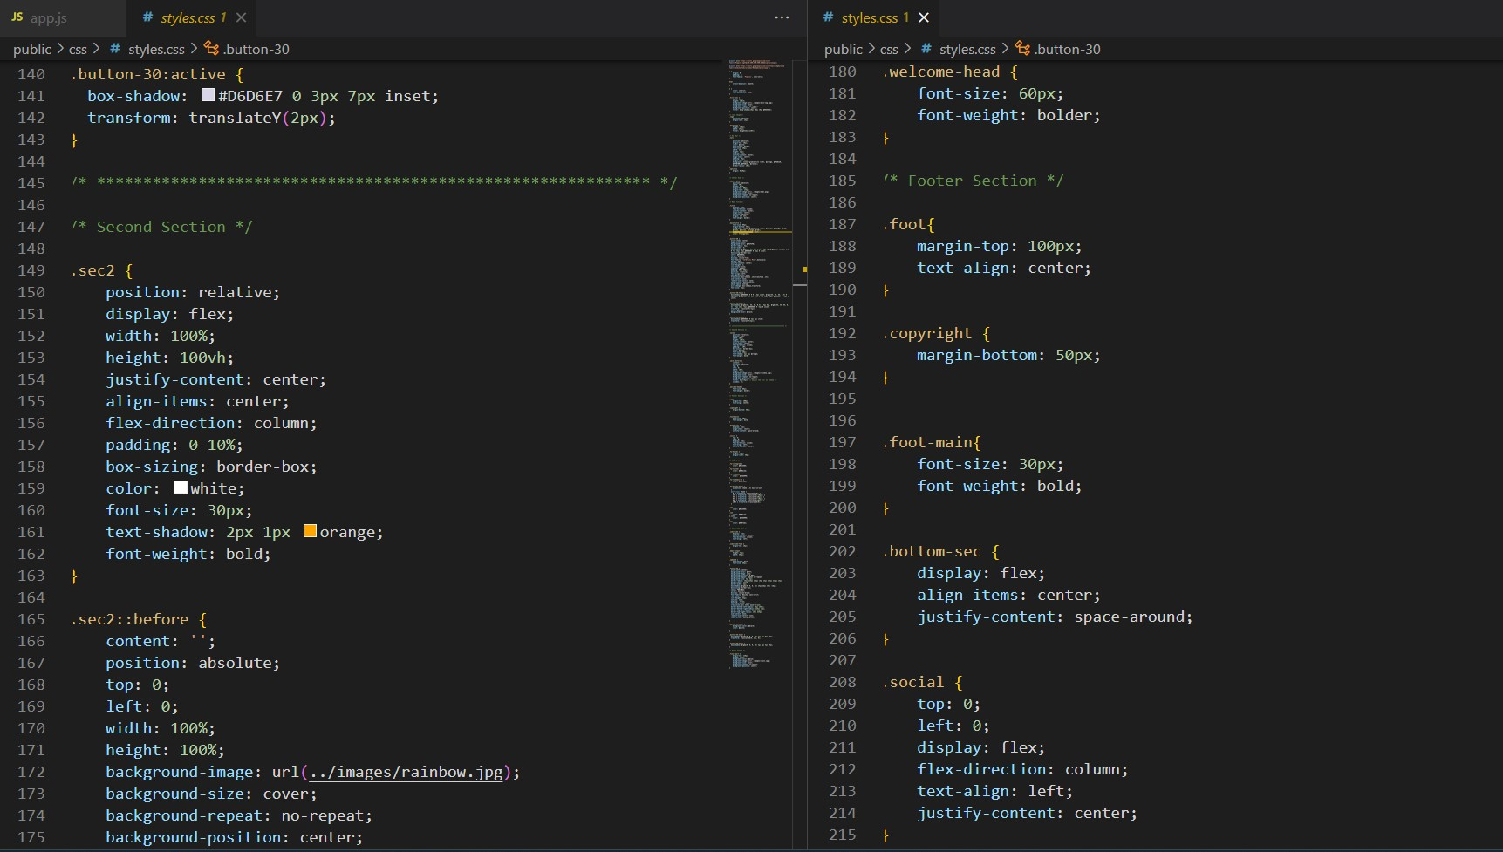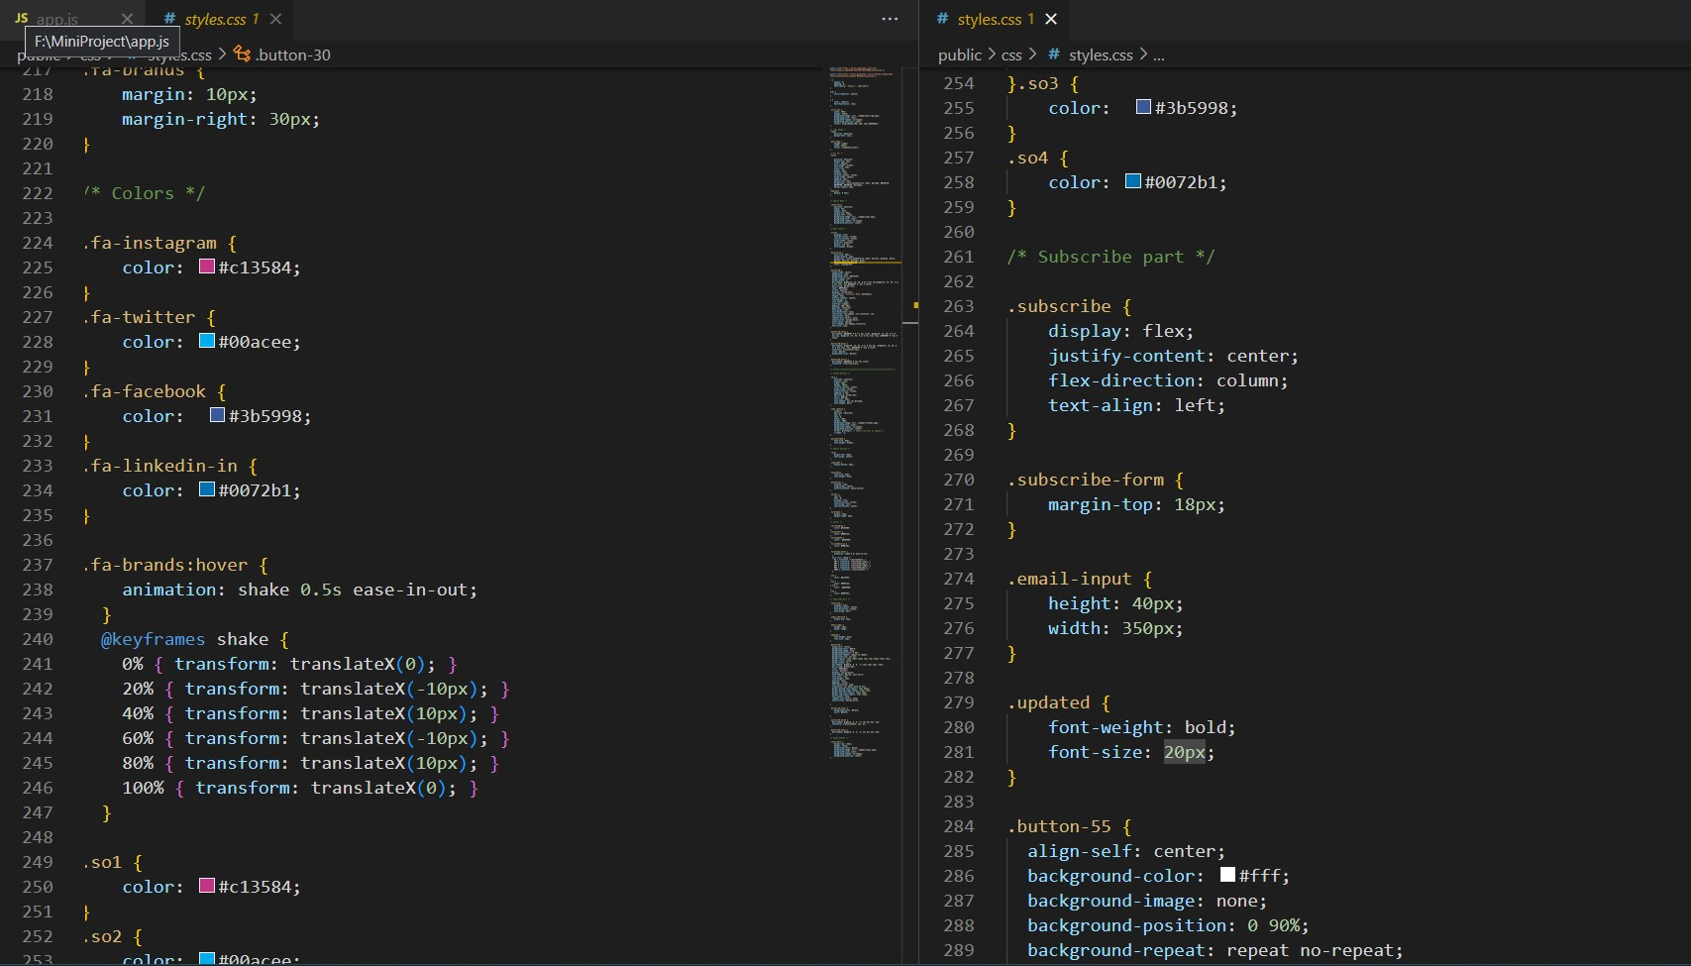

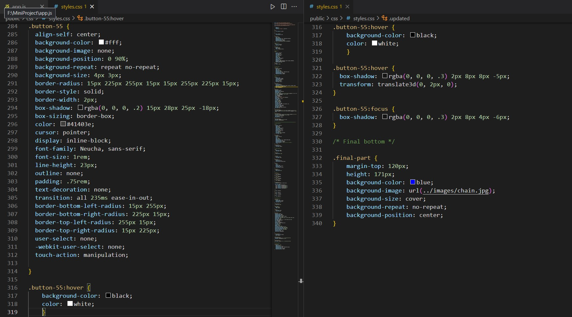

**3. Future Improvement**

1.**Database for User Progress:**

The addition of a database is crucial for storing and managing user data, specifically their progress within the application. This could include details such as completed quizzes, scores, achievements, and any other relevant information. 2.**Scoring System:**

A scoring system provides users with a quantitative measure of their performance, allowing them to track their improvement over time.

3.**New Quiz/Games:**

Continuously adding new quizzes and games keeps the application engaging and encourages users to return for fresh content.

**4.Conclusion:**

MiniMinds provides an exciting and educational platform for kids, combining a vibrant front-end with interactive quizzes and a robust backend infrastructure. The use of HTML, CSS, JavaScript, Node.js, Express.js, and PostgreSQL ensures a seamless and enjoyable experience for young learners. Through MiniMinds, we aim to contribute to the educational journey of children, making learning both fun and rewarding.



# Bibliography/ References

* www.mentimeter.com/blog/
* https://www.kidsquizdaily.co.uk/
* [www.udemy.com/course/the-complete-web-development-bootcamp/](http://www.udemy.com/course/the-complete-web-development-bootcamp/)
* https://www.youtube.com/results?search_query=apna+college